Study material

# Recommendation System Algorithms –

Main existing recommendation engines and how they work

Link - <https://blog.statsbot.co/recommendation-system-algorithms-ba67f39ac9a3>



# Introduction to Recommender Systems –

Contents – a PPT, 2 videos

Link - <http://technocalifornia.blogspot.in/2014/08/introduction-to-recommender-systems-4.html>

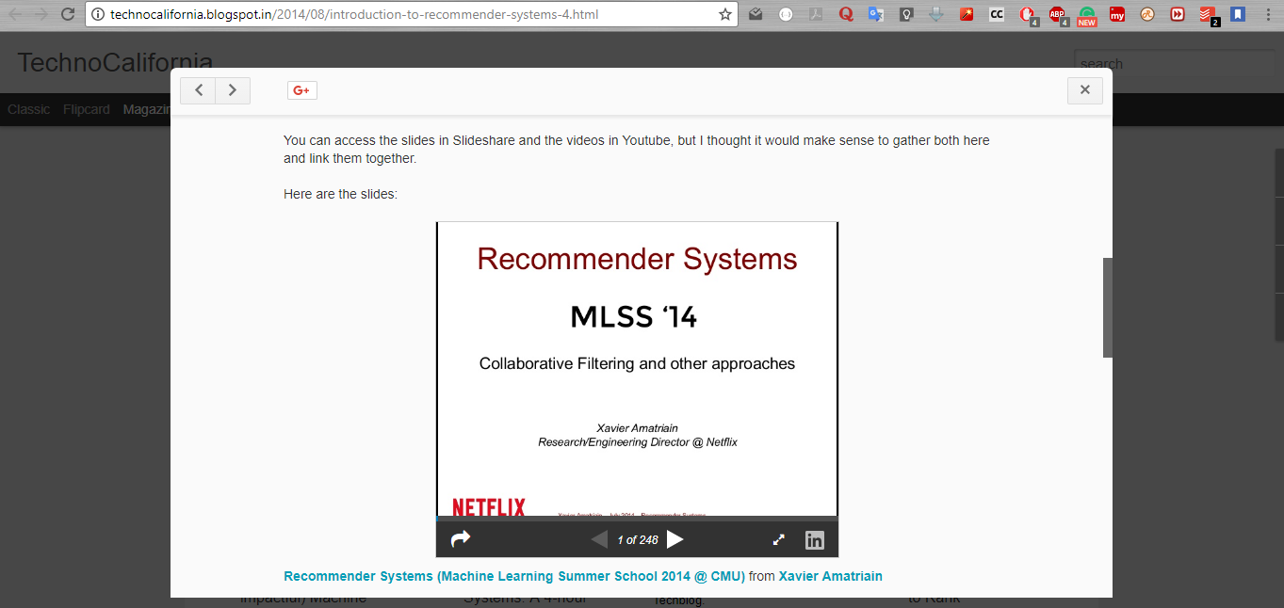

# How does LinkedIn's recommendation system work?

Link - <https://www.quora.com/How-does-LinkedIns-recommendation-system-work>

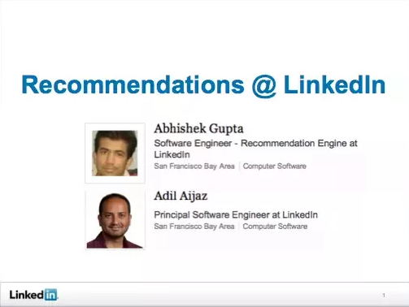

# Netflix Recommendations: Beyond the 5 stars (Part 1)

Link - <https://medium.com/netflix-techblog/netflix-recommendations-beyond-the-5-stars-part-1-55838468f429>

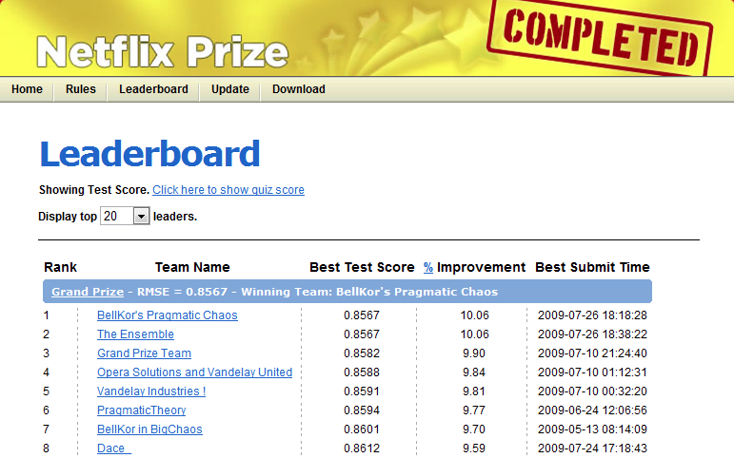

# Netflix Recommendations: Beyond the 5 stars (Part 2)

Link - <https://medium.com/netflix-techblog/netflix-recommendations-beyond-the-5-stars-part-2-d9b96aa399f5>